Number Operations
# Source: AI Source: Provided by: [Data Path: Persons Table -> ID Column: 1, Name_En Column: Motasem Essam] -> From: [ChatGPT] on [7/11/2026]
Number operations are mathematical processes performed on one or more numbers to obtain a new value or result. They form the foundation of arithmetic and are essential for solving mathematical problems and performing calculations in everyday life.
The four basic arithmetic operations are:
- Addition (+)
- Subtraction (−)
- Multiplication (×)
- Division (÷)
More advanced number operations include exponentiation, roots, modulus, percentages, logarithms, and others.

Definition

Definition:
# Source: AI Source: Provided by: [Data Path: Persons Table -> ID Column: 1, Name_En Column: Motasem Essam] -> From: [ChatGPT] on [7/11/2026]
A number operation is a mathematical procedure that combines, transforms, or compares numbers according to specific rules to produce a result.

Classification of Number Operations

A. Basic Arithmetic Operations

1. Addition (+)
# Source: AI Source: Provided by: [Data Path: Persons Table -> ID Column: 1, Name_En Column: Motasem Essam] -> From: [ChatGPT] on [7/11/2026]
Combines two or more numbers to find their total.
Example:
8+5=13

2. Subtraction (−)
# Source: AI Source: Provided by: [Data Path: Persons Table -> ID Column: 1, Name_En Column: Motasem Essam] -> From: [ChatGPT] on [7/11/2026]
Finds the difference between two numbers.
Example:
15−7=8

3. Multiplication (×)
# Source: AI Source: Provided by: [Data Path: Persons Table -> ID Column: 1, Name_En Column: Motasem Essam] -> From: [ChatGPT] on [7/11/2026]
Finds the product by repeated addition.
Example:
6×4=24

4. Division (÷)
# Source: AI Source: Provided by: [Data Path: Persons Table -> ID Column: 1, Name_En Column: Motasem Essam] -> From: [ChatGPT] on [7/11/2026]
Splits a number into equal parts or determines how many times one number contains another.
Example:
20÷5=4

B. Power and Root Operations

5. Exponentiation (Power)
# Source: AI Source: Provided by: [Data Path: Persons Table -> ID Column: 1, Name_En Column: Motasem Essam] -> From: [ChatGPT] on [7/11/2026]
Raises a number to a specified power.
Example:
3⁴=81

6. Square Root
# Source: AI Source: Provided by: [Data Path: Persons Table -> ID Column: 1, Name_En Column: Motasem Essam] -> From: [ChatGPT] on [7/11/2026]
Finds the number whose square equals the given number.
Example:
sqrt{49} = 7

7. Cube Root
# Source: AI Source: Provided by: [Data Path: Persons Table -> ID Column: 1, Name_En Column: Motasem Essam] -> From: [ChatGPT] on [7/11/2026]
Finds the number whose cube equals the given number.
Example:
sqrt[3]{64}=4

C. Division-Related Operations

8. Modulus (Modulo)
# Source: AI Source: Provided by: [Data Path: Persons Table -> ID Column: 1, Name_En Column: Motasem Essam] -> From: [ChatGPT] on [7/11/2026]
Returns the remainder after division.
Example:
17mod5=2

9. Integer (Floor) Division
# Source: AI Source: Provided by: [Data Path: Persons Table -> ID Column: 1, Name_En Column: Motasem Essam] -> From: [ChatGPT] on [7/11/2026]
Returns only the integer quotient.
Example:
17÷5=3
with remainder 2.

D. Signed Number Operations
# Source: AI Source: Provided by: [Data Path: Persons Table -> ID Column: 1, Name_En Column: Motasem Essam] -> From: [ChatGPT] on [7/11/2026]
Operations involving positive and negative numbers.
Examples:
−7+4=−3
5−(−2)=7
(−3)×4=−12

E. Absolute Value
# Source: AI Source: Provided by: [Data Path: Persons Table -> ID Column: 1, Name_En Column: Motasem Essam] -> From: [ChatGPT] on [7/11/2026]
Returns the distance of a number from zero.
Example:
∣−8∣=8

F. Fraction Operations

15. Addition of Fractions
# Source: AI Source: Provided by: [Data Path: Persons Table -> ID Column: 1, Name_En Column: Motasem Essam] -> From: [ChatGPT] on [7/11/2026]
1/2​+ 1/4​=3/4​

16. Subtraction of Fractions
# Source: AI Source: Provided by: [Data Path: Persons Table -> ID Column: 1, Name_En Column: Motasem Essam] -> From: [ChatGPT] on [7/11/2026]
3/4 – 1/4 = 3/4

17. Multiplication of Fractions
# Source: AI Source: Provided by: [Data Path: Persons Table -> ID Column: 1, Name_En Column: Motasem Essam] -> From: [ChatGPT] on [7/11/2026]
2/3 × 3/4 ​= 1/2​

18. Division of Fractions
# Source: AI Source: Provided by: [Data Path: Persons Table -> ID Column: 1, Name_En Column: Motasem Essam] -> From: [ChatGPT] on [7/11/2026]
1/2​ ÷ 1/4 ​= 2

G. Decimal Operations
# Source: AI Source: Provided by: [Data Path: Persons Table -> ID Column: 1, Name_En Column: Motasem Essam] -> From: [ChatGPT] on [7/11/2026]
- Addition of decimals
- Subtraction of decimals
- Multiplication of decimals
- Division of decimals
Example:
3.5+2.8=6.3

H. Rounding and Estimation
# Source: AI Source: Provided by: [Data Path: Persons Table -> ID Column: 1, Name_En Column: Motasem Essam] -> From: [ChatGPT] on [7/11/2026]
Rounding
Example:
37.68 rounded to the nearest whole number:
38
Estimation
Example:
198 + 301 ≈ 200 + 300 = 500

I. Scientific Notation
# Source: AI Source: Provided by: [Data Path: Persons Table -> ID Column: 1, Name_En Column: Motasem Essam] -> From: [ChatGPT] on [7/11/2026]
Expresses very large or very small numbers.
Example:
5,600,000=5.6×10⁶

G. Percentage Operations

10. Percentage
# Source: AI Source: Provided by: [Data Path: Persons Table -> ID Column: 1, Name_En Column: Motasem Essam] -> From: [ChatGPT] on [7/11/2026]
Expresses a number as parts per hundred.
Example:
20% of 80:
0.20×80=16

11. Percentage Increase
# Source: AI Source: Provided by: [Data Path: Persons Table -> ID Column: 1, Name_En Column: Motasem Essam] -> From: [ChatGPT] on [7/11/2026]
Example:
Increase 100 by 15%:
100+15=115

12. Percentage Decrease
# Source: AI Source: Provided by: [Data Path: Persons Table -> ID Column: 1, Name_En Column: Motasem Essam] -> From: [ChatGPT] on [7/11/2026]
Example:
Decrease 200 by 10%:
200−20=180

K. Ratio and Proportion

13. Ratio
# Source: AI Source: Provided by: [Data Path: Persons Table -> ID Column: 1, Name_En Column: Motasem Essam] -> From: [ChatGPT] on [7/11/2026]
Compares two quantities.
Example:
6:9=2:3

14. Proportion
# Source: AI Source: Provided by: [Data Path: Persons Table -> ID Column: 1, Name_En Column: Motasem Essam] -> From: [ChatGPT] on [7/11/2026]
States that two ratios are equal.
Example:
2:3=4:6

Order of Operations
# Source: AI Source: Provided by: [Data Path: Persons Table -> ID Column: 1, Name_En Column: Motasem Essam] -> From: [ChatGPT] on [7/11/2026]
The Order of Operations is a set of rules that determines the correct sequence for performing arithmetic operations in a mathematical expression. Following these rules ensures that every expression has a unique and consistent result, regardless of who performs the calculation.
Two of the most common mnemonics are:
- PEMDAS (Parentheses, Exponents, Multiplication, Division, Addition, Subtraction)
- BODMAS (Brackets, Orders, Division, Multiplication, Addition, Subtraction)
Although the names differ, PEMDAS and BODMAS represent the same mathematical order of operations.

Definition
# Source: AI Source: Provided by: [Data Path: Persons Table -> ID Column: 1, Name_En Column: Motasem Essam] -> From: [ChatGPT] on [7/11/2026]
The Order of Operations is the standard sequence used to evaluate mathematical expressions containing two or more operations.
The general order is:
- Parentheses / Brackets
- Exponents / Orders (Powers and Roots)
- Multiplication and Division (from left to right)
- Addition and Subtraction (from left to right)

Meaning of PEMDAS
# Source: AI Source: Provided by: [Data Path: Persons Table -> ID Column: 1, Name_En Column: Motasem Essam] -> From: [ChatGPT] on [7/11/2026]
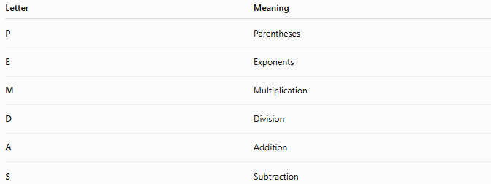
Letter | Meaning
P | Parentheses
E | Exponents
M | Multiplication
D | Division
A | Addition
S | Subtraction
Important:
Multiplication and division have equal priority.
Perform them from left to right.
Likewise,
Addition and subtraction also have equal priority and are performed from left to right.

Meaning of BODMAS
# Source: AI Source: Provided by: [Data Path: Persons Table -> ID Column: 1, Name_En Column: Motasem Essam] -> From: [ChatGPT] on [7/11/2026]
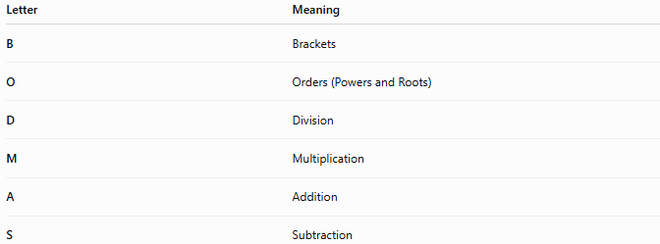
Letter | Meaning
B | Brackets
O | Orders (Powers and Roots)
D | Division
M | Multiplication
A | Addition
S | Subtraction
Like PEMDAS,
Division and multiplication have the same precedence,
and addition and subtraction have the same precedence.

Rules of the Order of Operations

1. Evaluate Parentheses (Brackets) First
# Source: AI Source: Provided by: [Data Path: Persons Table -> ID Column: 1, Name_En Column: Motasem Essam] -> From: [ChatGPT] on [7/11/2026]
Operations inside parentheses are performed before anything outside.
Positive Example
$$(4+6)×3 \\ =10×3 \\ =30$$
Negative Example
$$(-5+8)×4 \\ =3×4 \\ =12$$

2. Evaluate Exponents (Orders)
# Source: AI Source: Provided by: [Data Path: Persons Table -> ID Column: 1, Name_En Column: Motasem Essam] -> From: [ChatGPT] on [7/11/2026]
After parentheses, calculate powers and roots.
Positive Example
$$3^{2}+4 \\ =9+4 \\ =13$$
Negative Example
$$\left(-3)^{2}+4\right. \\ =9+4 \\ =13$$

3. Perform Multiplication and Division from Left to Right
# Source: AI Source: Provided by: [Data Path: Persons Table -> ID Column: 1, Name_En Column: Motasem Essam] -> From: [ChatGPT] on [7/11/2026]
Multiplication does not always come before division.
They have equal precedence.
Positive Example
$$24÷6×5 \\ =4×5 \\ =20$$
Negative Example
$$-24÷6×5 \\ =-4×5 \\ =-20$$

4. Perform Addition and Subtraction from Left to Right
# Source: AI Source: Provided by: [Data Path: Persons Table -> ID Column: 1, Name_En Column: Motasem Essam] -> From: [ChatGPT] on [7/11/2026]
Addition does not always come before subtraction.
They have equal precedence.
Positive Example
$$15-6+2 \\ =9+2 \\ =11$$
Negative Example
$$-15+6-2 \\ =-9-2 \\ =-11$$

5. Nested Parentheses Are Evaluated from the Innermost Outward
# Source: AI Source: Provided by: [Data Path: Persons Table -> ID Column: 1, Name_En Column: Motasem Essam] -> From: [ChatGPT] on [7/11/2026]
Evaluate the deepest parentheses first.
Positive Example
$$\left((2+3)×4\right) \\ =5×4 \\ =20$$
Negative Example
$$\left((-4+7)^{2}\right) \\ =3^{2} \\ =9$$

6. Fraction Bars Act Like Parentheses
# Source: AI Source: Provided by: [Data Path: Persons Table -> ID Column: 1, Name_En Column: Motasem Essam] -> From: [ChatGPT] on [7/11/2026]
Evaluate the numerator and denominator separately before dividing.
Positive Example
$$\frac{4+8}{2}=\frac{12}{2}=6$$
Negative Example
$$\frac{-6+10}{2}=\frac{4}{2}=2$$

7. Unary Negative Signs Apply Before Multiplication
# Source: AI Source: Provided by: [Data Path: Persons Table -> ID Column: 1, Name_En Column: Motasem Essam] -> From: [ChatGPT] on [7/11/2026]
Distinguish between
$$-3^{2}$$
and
$$\left( − 3)^{2}.\right.$$
Positive Example
$$\left(-3)^{2}=9\right.$$
Negative Example
$$-3^{2}=-(3^{2})=-9$$

Examples
# Source: AI Source: Provided by: [Data Path: Persons Table -> ID Column: 1, Name_En Column: Motasem Essam] -> From: [ChatGPT] on [7/11/2026]
Example 1
Evaluate
$$8+2×5 \\ =8+10 \\ =18$$

Example 2
Evaluate
$$(8+2)×5 \\ =10×5 \\ =50$$

Example 3
Evaluate
$$18÷3×2 \\ =6×2 \\ =12$$

Example 4
Evaluate
$$3^{2}+4×5 \\ =9+20 \\ =29$$

Example 5
Evaluate
$$\left(-2)^{3}+12÷3\right. \\ =-8+4 \\ =-4$$

Example 6
Evaluate
$$((6-2)^{2}+8)÷4 \\ =(4^{2}+8)÷4 \\ =(16+8)÷4 \\ =24÷4 \\ =6$$

Common Mnemonics
# Source: AI Source: Provided by: [Data Path: Persons Table -> ID Column: 1, Name_En Column: Motasem Essam] -> From: [ChatGPT] on [7/11/2026]
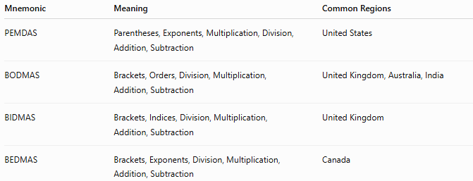
Mnemonic | Meaning | Common Regions
PEMDAS | Parentheses, Exponents, Multiplication, Division, Addition, Subtraction | United States
BODMAS | Brackets, Orders, Division, Multiplication, Addition, Subtraction | United Kingdom, Australia, India
BIDMAS | Brackets, Indices, Division, Multiplication, Addition, Subtraction | United Kingdom
BEDMAS | Brackets, Exponents, Division, Multiplication, Addition, Subtraction | Canada
All represent the same order of operations.

Properties
# Source: AI Source: Provided by: [Data Path: Persons Table -> ID Column: 1, Name_En Column: Motasem Essam] -> From: [ChatGPT] on [7/11/2026]
- Produces a unique result for every valid expression.
- Parentheses have the highest priority.
- Exponents are evaluated before multiplication and division.
- Multiplication and division have equal precedence.
- Addition and subtraction have equal precedence.
- Operations with equal precedence are evaluated from left to right.

Real-Life Applications
# Source: AI Source: Provided by: [Data Path: Persons Table -> ID Column: 1, Name_En Column: Motasem Essam] -> From: [ChatGPT] on [7/11/2026]
The Order of Operations is used in:
- Scientific calculators
- Spreadsheet software (Excel, Google Sheets)
- Programming languages
- Financial software
- Engineering calculations
- Physics formulas
- Statistical analysis
- Computer graphics
- Artificial intelligence
- Mathematical modeling

Real-Life Examples
# Source: AI Source: Provided by: [Data Path: Persons Table -> ID Column: 1, Name_En Column: Motasem Essam] -> From: [ChatGPT] on [7/11/2026]
1. Calculator Evaluation
Calculators automatically follow the order of operations when evaluating expressions.

2. Spreadsheet Formulas
Excel evaluates formulas according to the order of operations.
Example:
=5+3*4
returns
17
Not
32

3. Programming
Languages such as Python, Java, and C++ follow the same precedence rules.
Example:
5 + 3 * 4
evaluates to
17

4. Physics
Formulas involving multiple operations must follow the correct order to obtain accurate results.

5. Engineering
Structural and electrical calculations rely on consistent evaluation rules.

6. Financial Calculations
Loan payments, taxes, and interest calculations depend on the correct order of arithmetic operations.

Common Mistakes
# Source: AI Source: Provided by: [Data Path: Persons Table -> ID Column: 1, Name_En Column: Motasem Essam] -> From: [ChatGPT] on [7/11/2026]
- Performing addition before multiplication.
- Assuming multiplication always comes before division.
- Assuming addition always comes before subtraction.
- Forgetting parentheses.
- Confusing
$$-3^{2}$$
with
$$\left( − 3)^{2}.\right.$$
- Ignoring nested parentheses.

Key Points
# Source: AI Source: Provided by: [Data Path: Persons Table -> ID Column: 1, Name_En Column: Motasem Essam] -> From: [ChatGPT] on [7/11/2026]
- The Order of Operations determines the correct sequence for evaluating expressions.
- PEMDAS, BODMAS, BIDMAS, and BEDMAS all describe the same rules.
- Parentheses are evaluated first.
- Exponents are evaluated second.
- Multiplication and division have equal precedence and are evaluated left to right.
- Addition and subtraction have equal precedence and are evaluated left to right.
- Following these rules ensures consistent and correct mathematical results.

PEMDAS vs. BODMAS
# Source: AI Source: Provided by: [Data Path: Persons Table -> ID Column: 1, Name_En Column: Motasem Essam] -> From: [ChatGPT] on [7/11/2026]
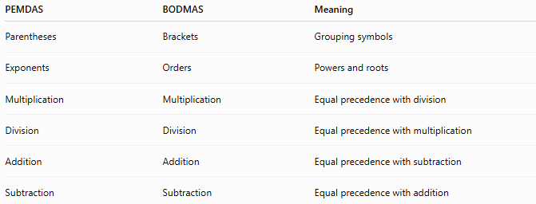
PEMDAS | BODMAS | Meaning
Parentheses | Brackets | Grouping symbols
Exponents | Orders | Powers and roots
Multiplication | Multiplication | Equal precedence with division
Division | Division | Equal precedence with multiplication
Addition | Addition | Equal precedence with subtraction
Subtraction | Subtraction | Equal precedence with addition

Conclusion
# Source: AI Source: Provided by: [Data Path: Persons Table -> ID Column: 1, Name_En Column: Motasem Essam] -> From: [ChatGPT] on [7/11/2026]
The Order of Operations provides the universal rules for evaluating mathematical expressions. Whether remembered as PEMDAS, BODMAS, BIDMAS, or BEDMAS, the principles are identical: evaluate grouping symbols first, then powers and roots, followed by multiplication and division from left to right, and finally addition and subtraction from left to right. These rules ensure that mathematical expressions are interpreted consistently in arithmetic, algebra, science, engineering, programming, and everyday

Simplifying Arithmetic Expressions
# Source: AI Source: Provided by: [Data Path: Persons Table -> ID Column: 1, Name_En Column: Motasem Essam] -> From: [ChatGPT] on [7/11/2026]
Simplifying Arithmetic Expressions is the process of evaluating a numerical expression by applying the Order of Operations correctly until a single numerical value is obtained.
A numerical expression may contain numbers, arithmetic operators, grouping symbols, exponents, roots, fractions, and other arithmetic operations. Simplifying the expression requires performing these operations in the proper order.

Definition
# Source: AI Source: Provided by: [Data Path: Persons Table -> ID Column: 1, Name_En Column: Motasem Essam] -> From: [ChatGPT] on [7/11/2026]
An Arithmetic Expression is a mathematical expression consisting of numbers and arithmetic operators, such as:
- Addition
- Subtraction
- Multiplication
- Division
- Exponents (Powers)
- Roots (Radicals)
- Absolute Value
- Parentheses (Grouping Symbols)
Simplifying an Arithmetic Expression means evaluating the expression step by step according to the Order of Operations until it becomes a single number.

Goal
# Source: AI Source: Provided by: [Data Path: Persons Table -> ID Column: 1, Name_En Column: Motasem Essam] -> From: [ChatGPT] on [7/11/2026]
The goal of simplifying an arithmetic expression is to:
- Obtain a single numerical value.
- Avoid ambiguity.
- Ensure consistent and correct calculations.
- Follow the standard order of operations.

Rules for Simplifying Arithmetic Expressions

1. Simplify Grouping Symbols First
# Source: AI Source: Provided by: [Data Path: Persons Table -> ID Column: 1, Name_En Column: Motasem Essam] -> From: [ChatGPT] on [7/11/2026]
Evaluate expressions inside grouping symbols before performing operations outside them.
Grouping symbols include:
- Parentheses ( )
- Brackets [ ]
- Braces { }
- Fraction bars
- Absolute value bars
Positive Example
$$(8+4)×2 \\ =12×2 \\ =24$$
Negative Example
$$(-6+10)×3 \\ =4×3 \\ =12$$

2. Simplify Exponents and Roots
# Source: AI Source: Provided by: [Data Path: Persons Table -> ID Column: 1, Name_En Column: Motasem Essam] -> From: [ChatGPT] on [7/11/2026]
Evaluate all powers and radicals before multiplication or division.
Positive Example
$$2^{3}+5 \\ =8+5 \\ =13$$
Negative Example
$$\left(-2)^{3}+9\right. \\ =-8+9 \\ =1$$

3. Simplify Multiplication and Division from Left to Right
# Source: AI Source: Provided by: [Data Path: Persons Table -> ID Column: 1, Name_En Column: Motasem Essam] -> From: [ChatGPT] on [7/11/2026]
Multiplication and division have the same precedence.
Positive Example
$$24÷6×5 \\ =4×5 \\ =20$$
Negative Example
$$-24÷6×5 \\ =-4×5 \\ =-20$$

4. Simplify Addition and Subtraction from Left to Right
# Source: AI Source: Provided by: [Data Path: Persons Table -> ID Column: 1, Name_En Column: Motasem Essam] -> From: [ChatGPT] on [7/11/2026]
Addition and subtraction have equal precedence.
Positive Example
$$18-6+4 \\ =12+4 \\ =16$$
Negative Example
$$-18+6-4 \\ =-12-4 \\ =-16$$

5. Simplify Nested Grouping Symbols from the Innermost Outward
# Source: AI Source: Provided by: [Data Path: Persons Table -> ID Column: 1, Name_En Column: Motasem Essam] -> From: [ChatGPT] on [7/11/2026]
Always evaluate the deepest grouping symbols first.
Positive Example
$$\left((3+5)×2\right) \\ =8×2 \\ =16$$
Negative Example
$$\left((-4+9)^{2}\right) \\ =5^{2} \\ =25$$

6. Simplify Fractions by Evaluating Numerator and Denominator Separately
# Source: AI Source: Provided by: [Data Path: Persons Table -> ID Column: 1, Name_En Column: Motasem Essam] -> From: [ChatGPT] on [7/11/2026]
Treat the fraction bar as a grouping symbol.
Positive Example
$$\frac{6+6}{3}=\frac{12}{3}=4$$
Negative Example
$$\frac{-8+12}{2}=\frac{4}{2}=2$$

7. Simplify Absolute Value Before Other Operations
# Source: AI Source: Provided by: [Data Path: Persons Table -> ID Column: 1, Name_En Column: Motasem Essam] -> From: [ChatGPT] on [7/11/2026]
Evaluate the absolute value first.
Positive Example
$$∣-8∣+3 \\ =8+3 \\ =11$$
Negative Example
$$∣-5∣^{2} \\ =5^{2} \\ =25$$

8. Reduce Negative Numbers Correctly
# Source: AI Source: Provided by: [Data Path: Persons Table -> ID Column: 1, Name_En Column: Motasem Essam] -> From: [ChatGPT] on [7/11/2026]
Apply sign rules throughout the simplification process.
Positive Example
$$6+(-4) \\ =2$$
Negative Example
$$-6-4 \\ =-10$$

Step-by-Step Simplification Examples
# Source: AI Source: Provided by: [Data Path: Persons Table -> ID Column: 1, Name_En Column: Motasem Essam] -> From: [ChatGPT] on [7/11/2026]
Example 1
Simplify
$$6+4×3$$
Multiply first.
$$6+12 \\ =18$$

Example 2
Simplify
$$(6+4)×3$$
Evaluate parentheses.
$$10×3 \\ =30$$

Example 3
Simplify
$$18÷3+5$$
Divide first.
$$6+5 \\ =11$$

Example 4
Simplify
$$3^{2}+8÷2$$
Exponent first.
$$9+4 \\ =13$$

Example 5
Simplify
$$\left(-3)^{2}+18÷6\right.$$
Exponent.
$$9+3 \\ =12$$

Example 6
Simplify
$$∣-7∣+2^{3}-5$$
Absolute value.
$$7+8-5 \\ =15-5 \\ =10$$

Applications
# Source: AI Source: Provided by: [Data Path: Persons Table -> ID Column: 1, Name_En Column: Motasem Essam] -> From: [ChatGPT] on [7/11/2026]
Simplifying arithmetic expressions is used in:
- Arithmetic
- Algebra
- Geometry
- Trigonometry
- Calculus
- Physics
- Engineering
- Computer Science
- Statistics
- Financial Mathematics

Properties
# Source: AI Source: Provided by: [Data Path: Persons Table -> ID Column: 1, Name_En Column: Motasem Essam] -> From: [ChatGPT] on [7/11/2026]
- Produces a single numerical result.
- Uses the standard order of operations.
- Eliminates ambiguity.
- Supports accurate mathematical reasoning.
- Applies to both positive and negative numbers.
- Works with integers, fractions, decimals, radicals, and exponents.

Real-Life Applications
# Source: AI Source: Provided by: [Data Path: Persons Table -> ID Column: 1, Name_En Column: Motasem Essam] -> From: [ChatGPT] on [7/11/2026]
Simplifying arithmetic expressions is used in:
- Scientific calculators
- Spreadsheet formulas
- Computer programming
- Financial calculations
- Engineering formulas
- Physics equations
- Tax calculations
- Data analysis
- Artificial intelligence
- Computer graphics

Real-Life Examples
# Source: AI Source: Provided by: [Data Path: Persons Table -> ID Column: 1, Name_En Column: Motasem Essam] -> From: [ChatGPT] on [7/11/2026]
1. Shopping
Calculate the total cost of several discounted items using the correct order of operations.

2. Engineering
Evaluate design formulas containing multiple arithmetic operations.

3. Programming
Programming languages evaluate arithmetic expressions according to the order of operations.

4. Spreadsheets
Excel and Google Sheets simplify formulas automatically.

5. Physics
Evaluate equations involving powers, roots, multiplication, and division.

6. Finance
Compute loan payments, taxes, and investment returns accurately.

Common Mistakes
# Source: AI Source: Provided by: [Data Path: Persons Table -> ID Column: 1, Name_En Column: Motasem Essam] -> From: [ChatGPT] on [7/11/2026]
- Ignoring the order of operations.
- Performing addition before multiplication.
- Performing multiplication before exponents.
- Forgetting grouping symbols.
- Misinterpreting negative signs.
- Confusing
$$-3^{2}$$
with
$$\left( − 3)^{2}.\right.$$
- Ignoring absolute value before continuing the calculation.

Key Points
# Source: AI Source: Provided by: [Data Path: Persons Table -> ID Column: 1, Name_En Column: Motasem Essam] -> From: [ChatGPT] on [7/11/2026]
- Simplifying an arithmetic expression means evaluating it to a single numerical value.
- Always follow the Order of Operations.
- Simplify grouping symbols first.
- Evaluate exponents and roots before multiplication and division.
- Perform multiplication and division from left to right.
- Perform addition and subtraction from left to right.
- Treat fraction bars and absolute value bars as grouping symbols.
- Correct handling of negative numbers is essential.

Order of Operations vs. Simplifying Arithmetic Expressions
# Source: AI Source: Provided by: [Data Path: Persons Table -> ID Column: 1, Name_En Column: Motasem Essam] -> From: [ChatGPT] on [7/11/2026]
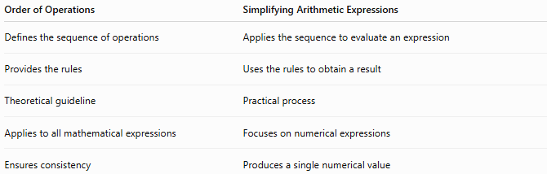
Order of Operations | Simplifying Arithmetic Expressions
Defines the sequence of operations | Applies the sequence to evaluate an expression
Provides the rules | Uses the rules to obtain a result
Theoretical guideline | Practical process
Applies to all mathematical expressions | Focuses on numerical expressions
Ensures consistency | Produces a single numerical value

Conclusion
# Source: AI Source: Provided by: [Data Path: Persons Table -> ID Column: 1, Name_En Column: Motasem Essam] -> From: [ChatGPT] on [7/11/2026]
Simplifying Arithmetic Expressions is the process of evaluating numerical expressions by applying the Order of Operations correctly. By simplifying grouping symbols first, then exponents and roots, followed by multiplication and division, and finally addition and subtraction, every arithmetic expression can be reduced to a single, unambiguous numerical result. This process is fundamental to arithmetic and forms the basis for solving problems in algebra, science, engineering, programming, finance, and many other disciplines.

Number Operations Examples in Real Life
# Source: AI Source: Provided by: [Data Path: Persons Table -> ID Column: 1, Name_En Column: Motasem Essam] -> From: [ChatGPT] on [7/11/2026]
1. Shopping
- Addition: Total cost of items.
- Subtraction: Change received.
- Multiplication: Price × Quantity.
- Division: Cost per person.

2. Banking
- Deposits and withdrawals.
- Interest calculations.
- Percentage increases.

3. Construction
- Area and volume calculations.
- Measuring materials.

4. Science
- Scientific notation.
- Exponents.
- Square roots.

5. Computer Science
- Modulo operations.
- Integer division.
- Binary arithmetic.

Applications
# Source: AI Source: Provided by: [Data Path: Persons Table -> ID Column: 1, Name_En Column: Motasem Essam] -> From: [ChatGPT] on [7/11/2026]
Number operations are used in:
- Arithmetic
- Algebra
- Geometry
- Statistics
- Physics
- Engineering
- Economics
- Computer Science
- Accounting
- Everyday calculations

Summary Table
# Source: AI Source: Provided by: [Data Path: Persons Table -> ID Column: 1, Name_En Column: Motasem Essam] -> From: [ChatGPT] on [7/11/2026]
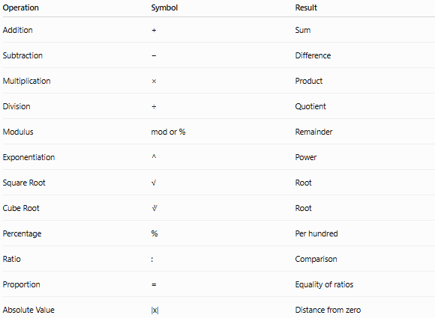
Operation | Symbol | Result
Addition | + | Sum
Subtraction | − | Difference
Multiplication | × | Product
Division | ÷ | Quotient
Modulus | mod or % | Remainder
Exponentiation | ^ | Power
Square Root | √ | Root
Cube Root | ∛ | Root
Percentage | % | Per hundred
Ratio | : | Comparison
Proportion | = | Equality of ratios
Absolute Value | |x| | Distance from zero

Conclusion
# Source: AI Source: Provided by: [Data Path: Persons Table -> ID Column: 1, Name_En Column: Motasem Essam] -> From: [ChatGPT] on [7/11/2026]
Number operations are the mathematical procedures used to manipulate numbers and solve problems. They begin with the four basic arithmetic operations—addition, subtraction, multiplication, and division—and extend to more advanced operations such as exponents, roots, percentages, ratios, fractions, decimals, and modulus. Mastering these operations provides the foundation for all higher-level mathematics and many practical applications in daily life.

